**Questions: Naïve Bayes**

X = {Sports, Blue, New, Yes}

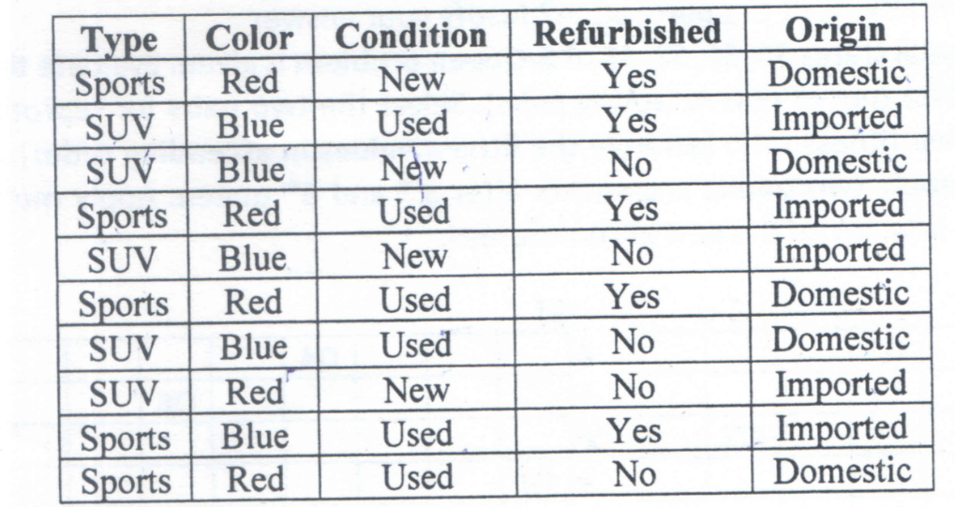

X = {yellow, ⌐sweet, long}

|  |  |  |  |  |
| --- | --- | --- | --- | --- |
| **Fruit** | **Yellow** | **Sweet** | **Long** | **TOTAL** |
| Mango | 350 | 450 | 0 | **650** |
| Banana | 400 | 300 | 350 | **400** |
| Others | 50 | 100 | 50 | **150** |
| **TOTAL** | **800** | **850** | **400** | **1200** |

**Question 2: K Means Clustering**

P2 and P7 are the initial clusters and perform two iterations

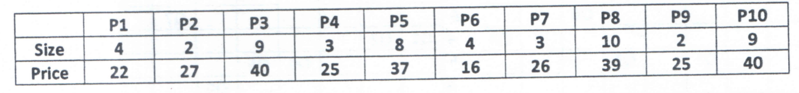

**Question 3: KNN using euclidean distance formula**

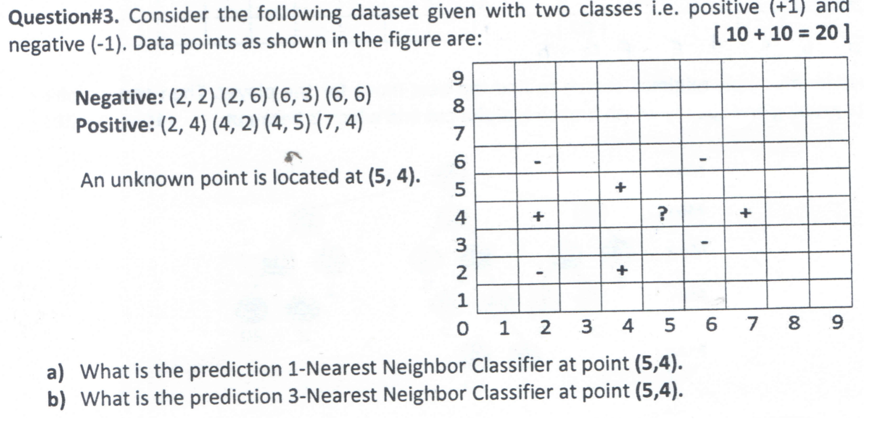

Question 4: Alpha-beta pruning

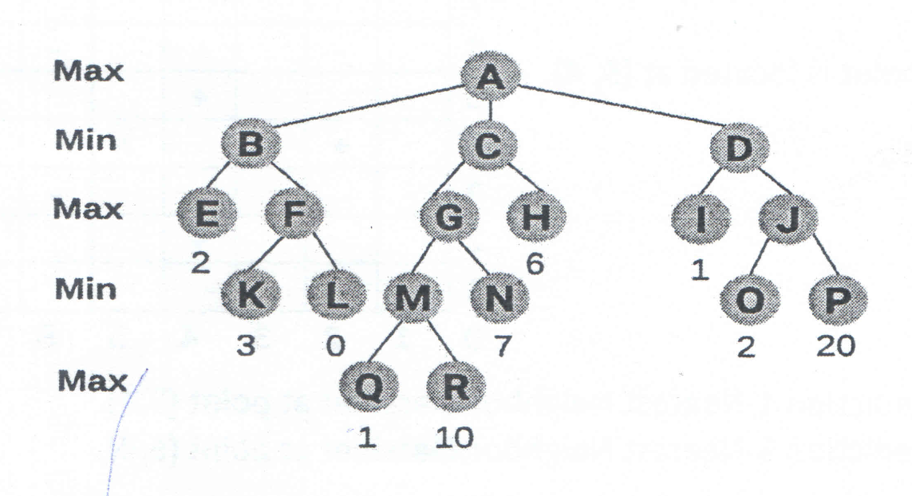

**Question 5: GA**

Select the two pairs for reproduction in accordance with their fitness ratio. For each pair to be mated apply two points crossovers after 3rd and 6th queen. Apply mutation by on last bit. Write the new chromosomes.

